Prayers from the Oodthenong Archdeacons & Area Deans

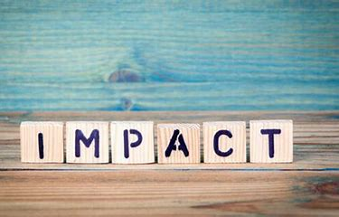 People’s whose work is impacted
Lord,
We pray for those whose employment has been impacted by the Virus. We pray that there will be a way through this difficult time for them just like a way was found for the Israelites in their escape from Egypt. Help those who have been impacted not to lose hope and see you provide in ways that could only come from you.
We pray in Jesus’ name,
Amen (Jon Taylor)

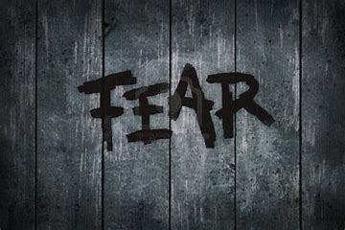 A prayer for our fears
God of peace
I know that you are always with me that you will never leave me nor forsake me
I share each anxious thought with You
I know that I am not alone
You understand my needs
Here I will shelter
safe within Your love
held by Your grace
and freed by Your truth
When I am afraid, I put my trust in you
Amen (Tim Johnson)

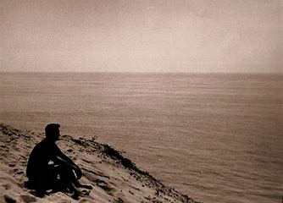 A Prayer for the isolated
Gracious and loving Heavenly Father,
Thankyou that in our weakness, we find your strength, in our fear we find the calmness of your peace and in our loneliness and isolation we find your presence.
We uplift to you all who are finding isolation from others difficult and challenging. Please comfort and strengthen them by your Holy Spirit. We pray they may know of your loving arms surrounding them and may their homes be filled by your grace and peace.
In Jesus’ name we pray
Amen (Gavin Ward)

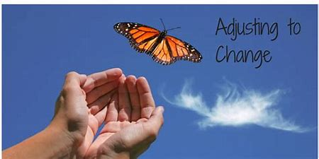 A prayer for opportunities, adjustment to change, spiritual needs
To our wonderful heavenly Father,
In the midst and uncertainty of this time in our history, we thank you that you promise to be with us, that we have not been given a spirit of fear, but of love, power and a sound mind. We thank you for the rhythm of our lives as we gather and scatter as the people of God from week to week.
As we are unable to gather in our traditional ways in the current season, help us to be salt and light in our homes and the limits the current pandemic is imposing upon us in terms of mixing and mingling with others. Help us to use the wonderful tools of technology to communicate well, contact one another and support all in our midst, particularly those that are anxious and afraid.
We are mindful that huge disruptions are not new to our world or your Church throughout the ages. We have been scattered by persecution (Acts 8:1) and pandemics in the past. Help us to be alert to new opportunities as leaders, as our world, role and modus operandi starts to be challenged or indeed needs to change. Help us to be alert to the needs of our communities as well as our own, that we might remain strong and be able to care for others.
In Jesus’ name we pray
AMEN (Dave Fuller)
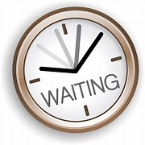 A Prayer for those waiting for test results and tested positive
Eternal God, our rock, our fortress and our protector:
be close to those waiting for test results, those who have tested positive for COVID-19,
and those who are unwell but not able to be tested. May the care of others reveal to
them your love that never leaves or forsakes us. in the midst of uncertainty and
anxiety, grant a deep trust in your unfailing goodness, that we may always find
our healing and peace in Jesus.
Amen. (Chris Lancaster)
A Prayer for People whose work is impacted and the financial hardship
Good and Gracious Father, To you alone can we appeal for our daily bread. We pray for all whose work is impacted and are facing financial hardship due to the Covid-19 pandemic. In particular we pray for countries and regions where their daily bread comes hand to mouth. We pray for generosity of neighbours, government leaders and others who have money, power and influence. In Australia we pray for hopeful migrants, international students and other travellers on short term visas that have no social welfare to fall back on. Help us to minister to their needs, for the love of your Son, who for our sake became poor, Jesus Christ our Lord. Amen.
(Simon Koefoed)
A Prayer for Death
This virus causes us to pause and consider our own mortality.
Christ has promised us eternal life, a full and rich life here on earth and later
in God’s Kingdom. So why do we still fear death? Is it the endings?
Is it the finality, the uncertainty, the sheer unknown quality of death?
Or is it the goodbyes, rather than cheerios, before we are quite ready to say them?
Perhaps, perhaps it is.
So in this time when we pause from usual life, We have a chance to reflect, to
recognise what we have always known, but choose to forget.
That we are carried by God, through all of life from birth to death and through every
day in between. We are carried in the palm of God’s hand. Today, relax, enjoy the pause, stretch back and feel the strength of that hand guiding you through life. Live life as Jesus taught us to love and love and love some more. And should that day come sooner than we had anticipated, when our life comes to an end; pray that we will have the grace and confidence to settle back into that callused hand, to trust that God will continue to carry us to an unknown but better understanding of our loving God. (Elizabeth Breakey)

A Prayer for Medical advances/progress towards a vaccine
Lord,
Creator of the heavens and the earth, of all that is seen and unseen, whose love and grace
knows no boarders and whose hand is a work in the hidden place of our lives and our world,
assist all who are on the front line working to combat the COVID-19 virus. We thank you for
the gifting of knowledge and pray for all scientists and epidemiologist that you might grant
them wisdom, knowledge and insight, as they search for an effective antiviral treatment,
and that they, and all medical professionals, may in this time of need and anxiety, be your
hands of healing, comfort and peace.

(Glenn Buijs)

