ABOUT PRAYING AND MEDITATING FOR A BENEFICIAL UNCOP 26.
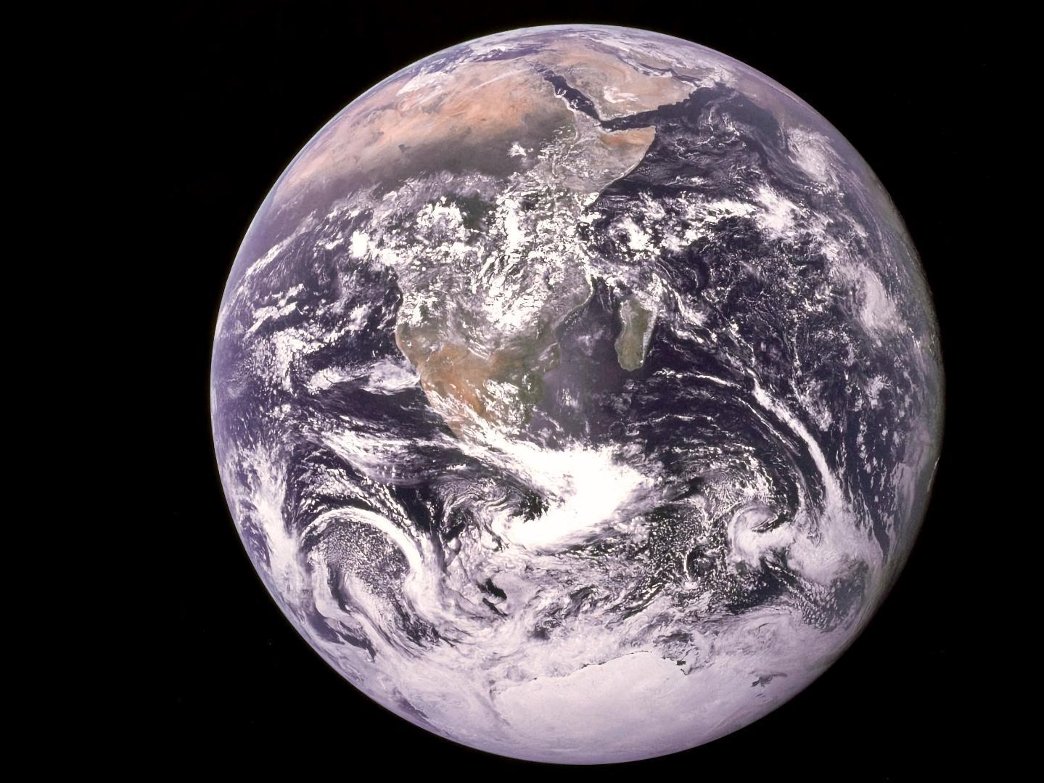
INTRODUCTION:

This Note encourages people of faith to offer their spiritual practice towards a beneficial UNCOP 26.
It is at the request of the Interfaith Liaison Committee to the UNFCCC that Ms Sarwat Tasneem and Bishop Philip Huggins have consulted and now offer these recommendations.

Aware of this as divine providence, two of us have been brought together to bring this Note to you.
After consultation, our recommendation is that people of faith join in three additional contributions through the days of UNCOP26.

HOW CAN YOU PARTICIPATE?

- *Noon each day: Silent Prayer and Meditation,perhaps with symbolic actions of our respective traditions- for example, ringing bells; lighting candles; standing silently together wherever we are.

- *7pm Deep Meditation and Prayer , according to our spiritual practice. Below is a prayer bidding from Lindsey Fielder Cook that can be used or for inspiration.

We, voices from faith communities across the world, join in prayer for meaningful decisions at the climate conference (COP26) in Glasgow.
We pray for courage and compassion to transform those human activities destroying nature and alter the climate system on which our lives depend.
We pray our hearts to reject fear and embrace love, hope and transformation for a more healthy, safe, clean and sustainable world. We pray for strength that our lives be patterns and examples.
We pray for protection of climate activists and environmental defenders, who often risk their health, if not their lives, to break silence.
We pray for protection of climate scientists to work without intimidation and with sufficient funding and support.
We pray for protection of the poor and most vulnerable communities, those least responsible yet most affected by our insufficient climate action.
We pray that our leaders listen to grasp the urgency expressed, in the latest science, and to guide our economic systems to reject dependance on extraction, exploitation and accumulation through dispossession.
We pray for wisdom, courage and compassion in our climate negotiators, to find shared solutions together that honour needs of the poorest, which reflecting meaningful action from the richest and highest emitters.
We pray the developed countries will lead in greenhouse gas emissions and climate finance, as they promised in the Paris Agreement.
We pray leaders in all countries will do all they can to rapidly reduce extraction and burning of fossil fuels, and promote sustainable economic, social and political systems to stabilize global temperature rise at 1.5C above pre-industrial levels.
We pray that developed countries meet their promise of 100 Billion dollars a year to help developing countries implement climate action, money in the form of grants rather than loans.
We pray for sufficient finance to Loss and Damage, supporting those communities already profoundly affected by climate change no matter what we do.
We pray for the completion of the Paris Agreement Rulebook, including ambitious, effective and fair compliance in common time frames and transparency in reporting.
We pray for human rights and Indigenous People’s Rights to be included and protected in the Rulebook language, including protection of these rights in carbon trading schemes.
We pray for an inclusive conference, in which the voices of the least powerful are heard alongside the most powerful.
We pray, in this pandemic time, that access to vaccines is a human right for all, and that delegates attending the COP remain healthy and covid-free.

3. *5-7 November: A Pilgrimage Weekend of “Faiths for Climate Justice COP26”.This will be ahead of the crucial final week of COP negotiations.

Saturday 6th November: “Faiths for Climate Justice COP26 - International”

As with all pilgrimages, the physical element is there to challenge the emotional and psychological. Reflection is the essence of all journeys. A mid-COP26 program will provide a platform for delegates, visitors and participants near and far to recharge spiritualily and to re-centre on their own journey.

Ahead of the crucial final week of COP negotiations, this
weekend of deep contemplation, meditation and prayer, will bring people and communities together across cities and countries on the 6th November.
Within a 24 hour window, across countries globally, for 1 hour leading up to a 12 noon silent prayer (local time) – we invite faith groups, and communities to come together in a symbolic act of unity for climate change. This can be reflected in an appropriate manner .
We envisage a virtual and in-person journey of reflection and connection for the good of this common cause.

SILENCE IS RELIGIOUSLY NEUTRAL.

Our experience from interfaith involvement is that silent prayer and meditation allows us to each make our spiritual contribution.

Many of you will have already resolved to make such contributions to the COP. Others of you may be helped by some elaboration and by a little clarity as to who brings this request to you and why.

A PERSONAL NOTE BY BISHOP PHILIP HUGGINS.

I have been an Anglican Bishop for many years. In recent years I have felt compelled to do what I can to prevent catastrophic climate change.

My years of ecumenical / interfaith work and political advocacy may have better prepared me for this.

In any case , I recognise that the climate crisis is beyond anything we have ever experienced and that we have little time left to prevent catastrophic climate change.

Hence ,like many I have been focused on advocacy towards a very successful UNCOP 26.

Continuing to do what is possible , I also know our prayers and meditations can transform the atmosphere in which the UNCOP will take place.

Obviously I am a disciple of Jesus .

Everything about Jesus helps one be aware of the love which God has for all creation.

Granted some insight into the divine love, in response I have learned to pray and meditate in my heart “ Jesus have mercy”.

I pray this prayer of compassion and this prayer prays in me . I find “ Jesus have mercy” starting up again and again in me throughout the day.

All this happens silently.

Beholding the love of God for all creation has no boundaries. Everything and everyone is included.

With beloved friends, I am drawn to offer prayers for the miraculous transformation of our planetary life at this time.

A focus is these October and November days up to and including UNCOP26.

We understand the difference between a holy place with a holy atmosphere and one that needs a transfiguring influence.

Our disfigured world needs our loving prayers and meditations..
A PERSONAL NOTE BY MS.SARWAT TASNEEM

My many years of working with faith communities and interfaith groups across the UK, in the Middle East and New Zealand, always drew on the shared commitment of justice.

Leaving an imprint and hope for equity and sustainability is important, particularly for our future generations.
We must work together, collaborate and be in synch with the natural world in order to limit the destruction that may well befall on our children and their children through climate change. We can not do this on our own.

My participation as a COP26 Faiths Advisor and advocate for indigenous peoples in the Global South, has highlighted the plight of the most vulnerable. Where lush marshes once flowed, droughts have ensued. Where oceans once provided foods for the most humble, anxiety and poverty increase.

Yet Faith and spirituality remain and prosper, and the connection to land, seas, oceans and skies is a constant reminder of our duty.
Now is the time for compassion and prayer.

As a Muslim, the act of salāh – with it’s Arabic literal root in invocation is defined as the daily prayer(s). The other is du’aā which is the supplicatory invocation, a conversation with God which can occur at any time in any location, in silence too.

When praying with a consciousness of both mind and a deeper connection of the heart, one in turn is in direct conversation with God.

Being aware of one’s self and gaining knowledge, forms the foundation of the incumbent act of servitude. More importantly, utilising this in practice. As the Qu’ran states

“O believers, look after yourselves, if you are on the right path you will not be harmed. (5:105)

Self-care is vitally important. A mechanism in Islam that is deemed as a tool to assist in our social responsibilities; to all of creation – this includes the natural environments we live in and take from.

In providing a safe place of sanctuary and spirituality during UN COP26 virtually and in person, we can come together and unite in prayer and silence, for the betterment of our world.

Through my work in and Mental Health & Wellbeing , the ability to find solace in silence and be conscious to one’s thoughts, benefits the mind and body.

As mentioned,we are part of the International Liaison Committee.

More information on the ILC is available on the website:

https://interfaithliaisoncommittee.carrd.co/

To begin these profoundly important days , the ILC is organising an :

Informal Interfaith Gathering in the Spirit of Talanoa Dialogue @COP26:

31 October 2021 4.30 pm-9.00 pm BST

This will be at the Garnehill Synagogue in Glasgow and Online.

This will involve Small group discussions on the crucial topics in Lindsey’s prayer biddings above ,followed by an Interfaith Service..

Joining together ,those in Glasgow and those Online ,will be a wonderful way to begin our special contribution - Praying and meditating for a Beneficial UNCOP26.

Registration: Eventbrite link with flyer

